Template Fire
Template National Forest
Long-term Assessment and Implementation Plan

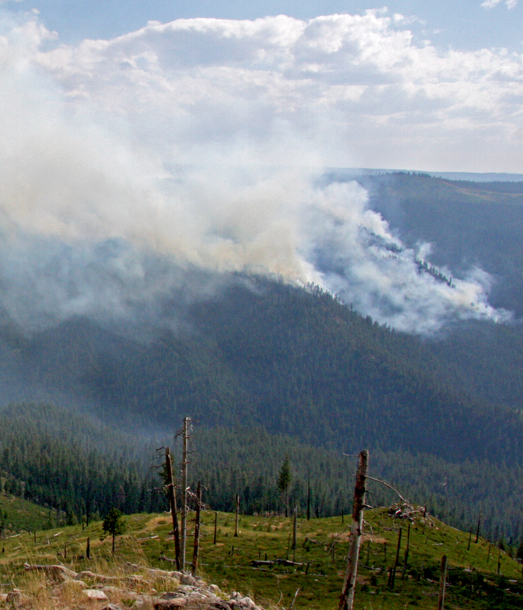

By R6 Long-term Assessment Team

Table of Contents
Executive Summary 3
Introduction 5
Objectives and Risk Assessment 5
Risk Assessment Considerations 5
Management Actions Points (MAP) 5
Fire Behavior 12
Fuels 15
Fire Growth 18
Longterm Outlook 21
Season Severty Indicator 21
Long Range Forecast 22
Risk Assessment 25
Communication 28
Appendix A - Point of Concern 29
Appendix B- FSPro Analysis 35
Appendix C – RERAP Map 43
Appendix D - Behave Summary 44
Appendix E – Coomunication Plan 45
Appendix F – Cost 53

Long-term Assessment Team:
LTAN – Long-term Fire Analyst trainee – FEMO trainee
PSC – Planning Section Chief FOBS – Field Observer/GISS(t)
trainee – Long-term Fire Analyst(t) FBAN – Fire Behavior Analyst
OSC– Operation Section Chief
Forest Assistance
Media gal – Public Affairs Cost guy – Cost
Executive Summary

Fuels
- Fuels in area
- Past treatments and effects*
- Current seasonal status of fuels.*

Fire Spread
- Short term spread.
- Longer term.

Long –term
- Season synopsis and outlook.*
- Climatological forecasts.*
- Season ending.*
- Characterization of fire growth days
- Risk assessment for points of concern.
- Landscape pattern and effects on future spread.
- Recommended future actions

Management Action Points
- MAP overview.
- Use of past tmts to improve MAPs.
- Dynamic nature of MAPs.
- Future years and opportunities.

* = information that could be provided, in whole or in part, by NWCC Predictive Services
- Introduction
How did we get here?

What was the charge to the team?.

Objectives and Risk Assessment
- Objectives given to team by unit
- Additional key questions to be addressed

Risk Assessment Considerations

- Identification and list of values at risk, source

Management Action Points (Mitigation Actions) for the North Fork Complex

MAP discussion (completed by OPS section)

Management Action Point Descriptions

MAP 1 –.description
MAP 2 –
MAP 3 –
MAP 4 –
MAP 5 –
MAP 6 –
Management Action Point Details

MAP # | Objectives/Conditions | Action/  Probability of Success | Resources Needed/  Cost | End Date
MAP 1 | Objective:  Condition: | A.  B.  Probability of Success: % | A. .  B.  Cost: A- $  B -  Total
Consequences of not implementing: .
MAP 2 | Objective:  Condition: | A.  B.  Probability of Success: % | A. .  B.  Cost: A- $  B -  Total
Consequences of not implementing:

See Appendix F for cost details

MAPmap
Map 1 – Management Action Point

Fire Behavior
(completed by FBAN, if assigned) – this section focuses on topography, weather, fuels in the fire vicinity
Narrative of observed fire behavior thus far

Topography
The template Forest is in the template physiographic providence which provides very diverse topography. The template drainage is a dynamic drainage with steep heavily timbered slopes. South of the template drainage the terrain becomes more rugged and diverse, the result of diverse underlying geology.

Weather
Climate of area, physiographic influences, summer weather patterns and fire season

Fire weather forecast zone, location of forecasts and outlooks.

RAWS sites used in assessment. Development of SIG? table of RAWS sites,
STATION | RAWS NUMBER | ELEVATION | DISTANCE

Our analysis includes the interaction between precipitation and fuel dryness. Specifically, we have used FireFamily Plus to look for historic precipitation events that would correlate to the current situation.

Fire Family Plus - Event locator - Precipitation
Fire Family Plus software was used to search for weather events that are key to questions in this assessment.

Relevant graphs

Figure 1

Figure 2

Figure 3

More narrative about recent weather and outlooks as related to key questions.

Summary of The NWCC Predictive Services product 7 Day Significant Fire Potential projection ,

Fuels
The fuels discussion occurs in two sections: 1) the natural fuel complexes associated with the immediate and 2) the surrounding areas.

Fire Vicinity
Fuels, fire behavior observed, local weather influences on behavior, broken out by areas in vicinity as appropriate, projections for fire behavior in adjacent fuels
Fuels condition map

Fire Growth Events

Description of historical fire growth events in the vicinity – triggers, weather influences, winds, Haines, synoptic weather, etc.

Table 1: Fire weather/fuels/NFDRS index conditions during historical periods of rapid fire growth

Figures for historical growth events
Figure 5

Projections for frequency of future fire growth events.

Long Term Outlook

The long term outlook and seasonal severity prognosis is based on weather records at the template Remote Area Weather Stations, as well as several sources of climatological information including but not limited to the Climate Prediction Center, the Western Regional Climate Center, Natural Resources Conservation Service, and the National Climate Data Center. We also used several evaluation tools including Fire Family Plus, Fire Spread Probability (FS Pro), and the Rare Event Risk Assessment Process (RERAP).

Seasonal Severity Indicators

Energy Release Component
Energy Release Component (ERC, using Fuel Model G) is a measure of the longer term large fuel dryness, and is a good indicator of fire season severity. description of seasonal patterns for severity indicators

Figure 8 - ERC graph for the template SIG with ERC projected from date to date based on Predictive Services forecasts.

Large Fuel Moisture
Other measures of seasonal dryness and potential fire behavior are the calculated hundred (100) and thousand (1000) hour fuel moistures (large dead woody fuels). Seasonal description

Figure 9: 100 hour fuel moisture calculated from daily weather observations at the template RAWS, highlighting data to date, and projecting 100hr fuel moisture from date to date.

Long Range Forecast

Long range forecast and projected fire activity

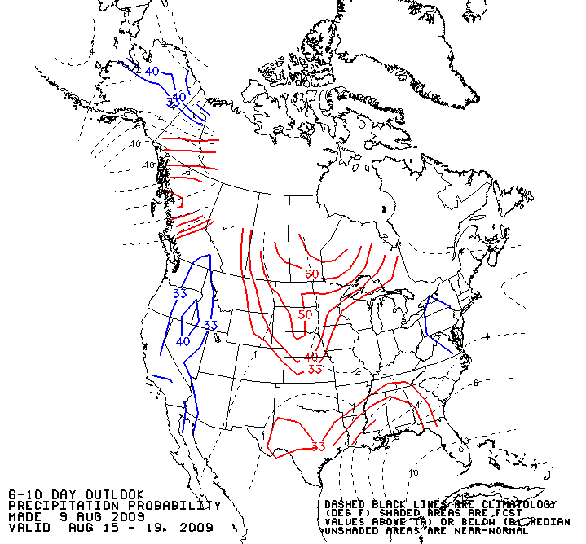
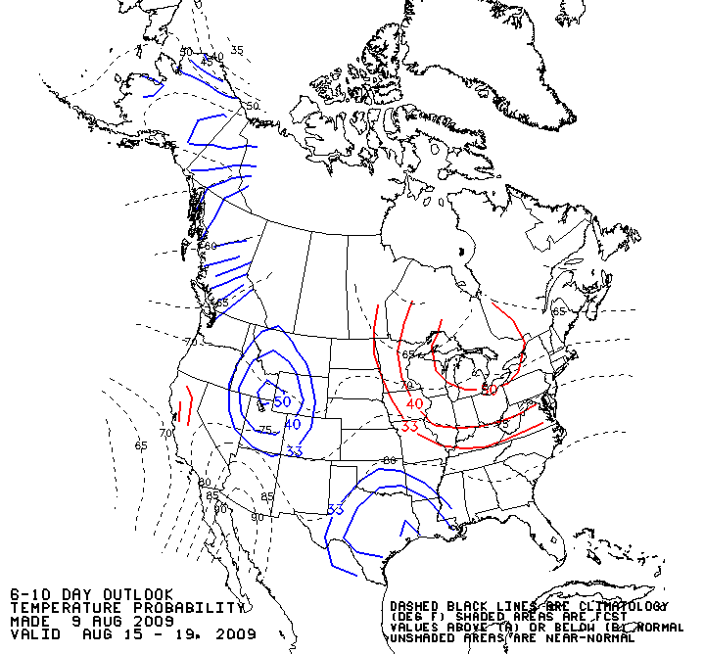

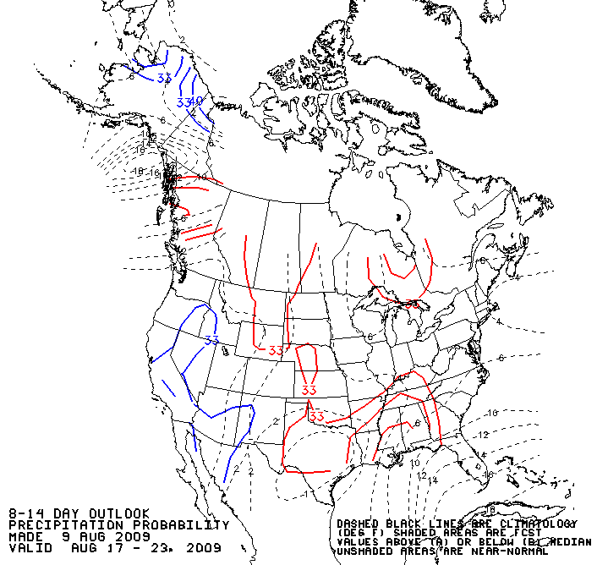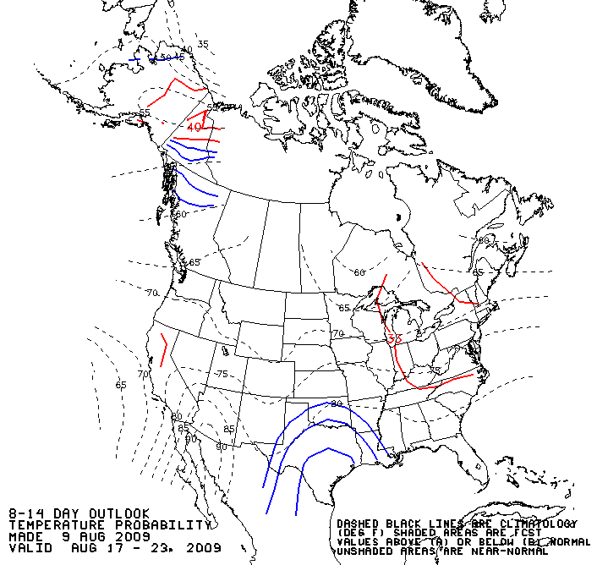

Figure 10 – 6-10 day and 8-14 day probabilities of temperature and precipitation for the continental US. Near normal temperatures and above normal precipitation are the most likely

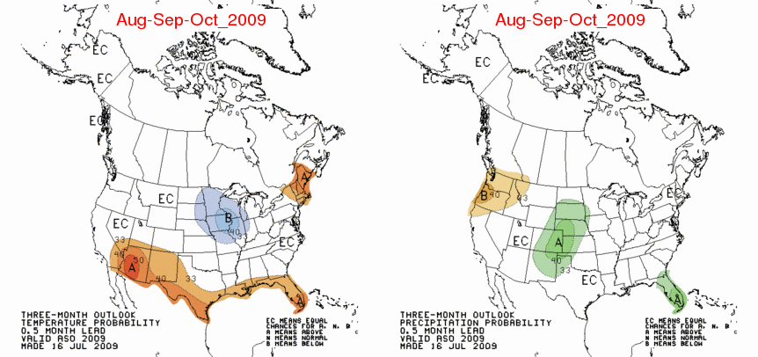
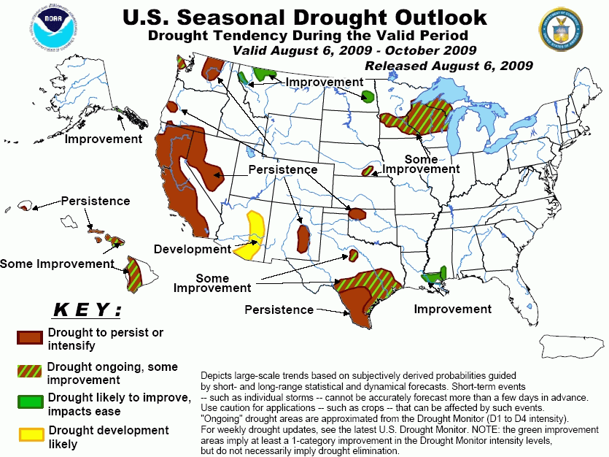
Figures 11: outlooks for temperature, precipitation, and drought conditions for the continental United States, date to date. The inland Pacific Northwest is forecasted to have a drier than late summer and early fall.

Season Slowing Events

Typical summers include periods of little to no fire growth, often as a result of precipitation that temporarily slows fires. We defined a fire-slowing event as x and y over a z period between date and date. On average, about xof these events occurred per year over the past 25 years as recorded at the template RAWS site.

Season Ending Events

The potential length of the fire season is important to operational and other management decisions, as the number of burn days left in the season have a direct effect on the likelihood that a free-burning fire will reach any point of concern. Local observations on the template National Forest indicate that active fire behavior and large fire growth are uncommon starting around the date.

Season ending dates were developed from the past 20 years of RAWS data collected at the template RAWS station. A season ending event was defined as a y and z.

Figure xx displays the result of this analysis. date is the midpoint date; by this date, 50% of fire seasons in the 20 years’ records had ended. By date, there is a 90% chance that the season will be over. This assessment compares well with some other available estimates of season-ending dates. The Northwest Interagency Coordination Center Predictive Services group calculates season ending dates differently, emphasizing 100hr fuel moisture and fire occurrence data, across the entire PSA (). This measure lines up well with the analysis based on rainfall and ERC; date is the 50th percentile date for season ending, and date is the 90th percentile date.

Term file
Figure 12 – RERAP evaluation of season ending dates. As indicated by highlighted coordinates, date is the 50th percentile date for season ending, and date is the 90th percentile date.

Risk Assessment

Fire Growth Projections
The Rare Event Risk Assessment Process (RERAP) and Fire Spread Probability (FSPro) were both used to evaluate fire spread potential. RERAP evaluates the probability that a free-burning fire will reach a particular point of concern before a season-ending weather event, creating essentially a “race” between a spreading fire and fall rains. FSPro, on the other hand, is a spatial model that calculates the probability of fire spread in all directions from a current fire perimeter or ignition point. FSPro models fire spread of hundreds or thousands of weather scenarios based on local climatological records to determine the probability of a fire spreading through an area over a given time period. Both RERAP and FSPro can be used to identify the probability that areas of concern could see fire. The outputs are helpful for developing priorities and analyzing values at risk.

Figure 13: Fire Spread Probability (FSPro) analysis for the template fires, template NF, for the period date to date.

FSPro evaluates the likelihood that a free-burning fire reaches any given piece of ground during the assessment period. The team conducted x FSPro analyses: one for ydays and one for z days. There were xx points of concern that the local unit identified – yy,zz,aa. This analysis indicates x threat to xx, a y chance of fire near yy, and z% of the fire reaching zz within aa days. .

FSPro also provides a histogram of fire sizes from the 3008 simulations. description

Appendix xx provides the details of the RERAP analysis. Narrative of same.

Assessment date | Total Risk – xx | Total Risk – yy | Total Risk – zz
Table 2 summary of RERAP analysis for likelihood a free-burning fire reaches the three points of concern.

The utility of this analysis is that it is clear that the later the fire crosses the a, the less chance it reaches any of the three points of concern by end of season.

Smoke Management
Smoke sensitive receptor areas have been identified by the State of template. These areas are provided the highest level of protection under the smoke management plan because of their past history of smoke incidents, density of population or other special legal status related to visibility. The closest communities that are designated are:

Smoke monitoring equipment available, and where. Real time air quality monitoring data is available on the web at http://www.deq.state.or.us/lab/aqm/airMonitoring.htm.

The x Wilderness and the y National Recreation Area are class 1 airsheds, and are located z of the fire area. No impacts to these airsheds from the template fires have yet been identified, and none are likely given the distance from the fire to these area.

Recommended Monitoring Actions:

The following monitoring actions are recommended for the duration of this season.

- .

Conclusions and Recommendations:

Communication
With the assistance of the Forest Public Affairs Office a long-term implementation plan was developed. This will be an on-going event and should be updated as needed. For details and action item, go to Appendix

